Did you know?

The average home leaks 22 gallons of water a day. The most common culprits of all this waste are leaking toilets and dripping faucets. Small leaks can add up to thousands of gallons of water wasted each year. Leaks that go undetected and unrepaired can cost you hundreds.

Do you have a leak?

Is your toilet running when no one is around? Is your kitchen sink dripping? Have you noticed a sudden discoloration in your walls? Are there unexplainable wet spots in your yard? You may have a leak. Use the following procedure to identify if you have a leak.

Make sure no water is running in your house (toilets flushing, wash machine running, faucets, etc.) Do not turn off your water main valve.

Before you find your meter, you will need the following items:
- A pair of channel locks or pliers
- A rag and a spray bottle full of water

Your meter crock is usually located near the road. If you have a white box like the one pictured below, your crock is nearby. You might have to move some debris to access the lid.
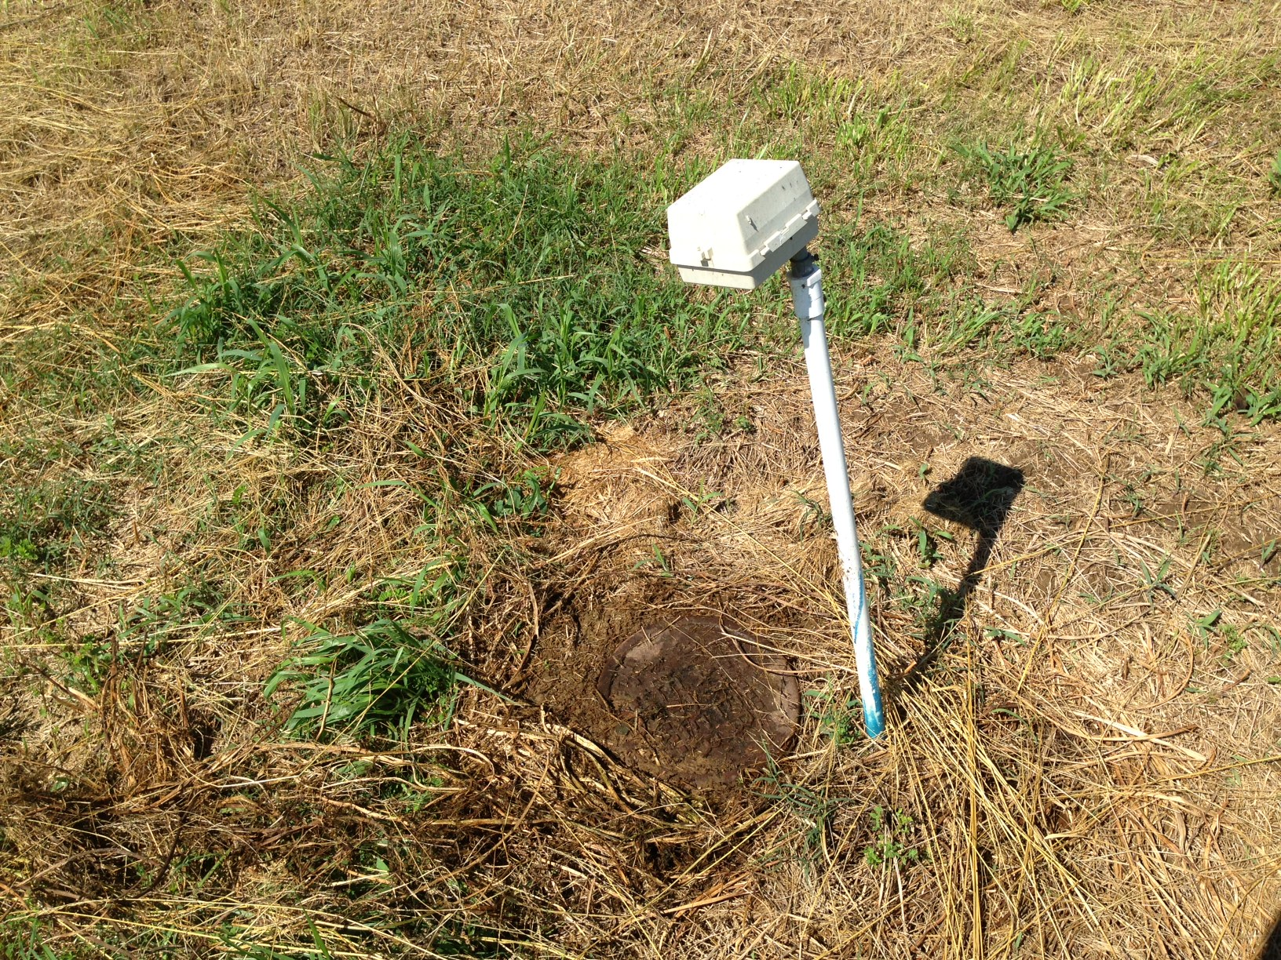
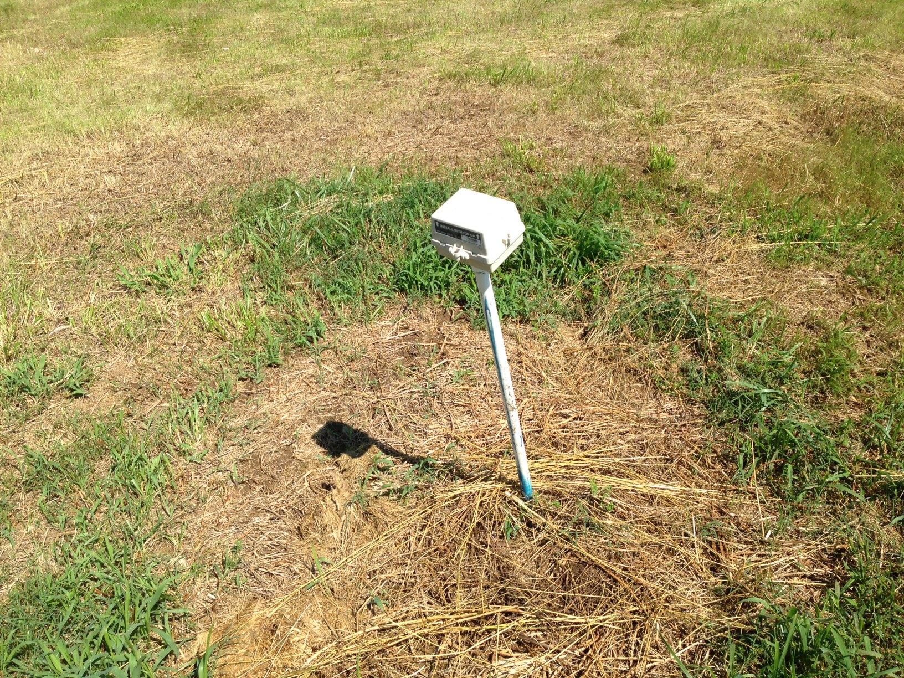
Once you
Common Leaks

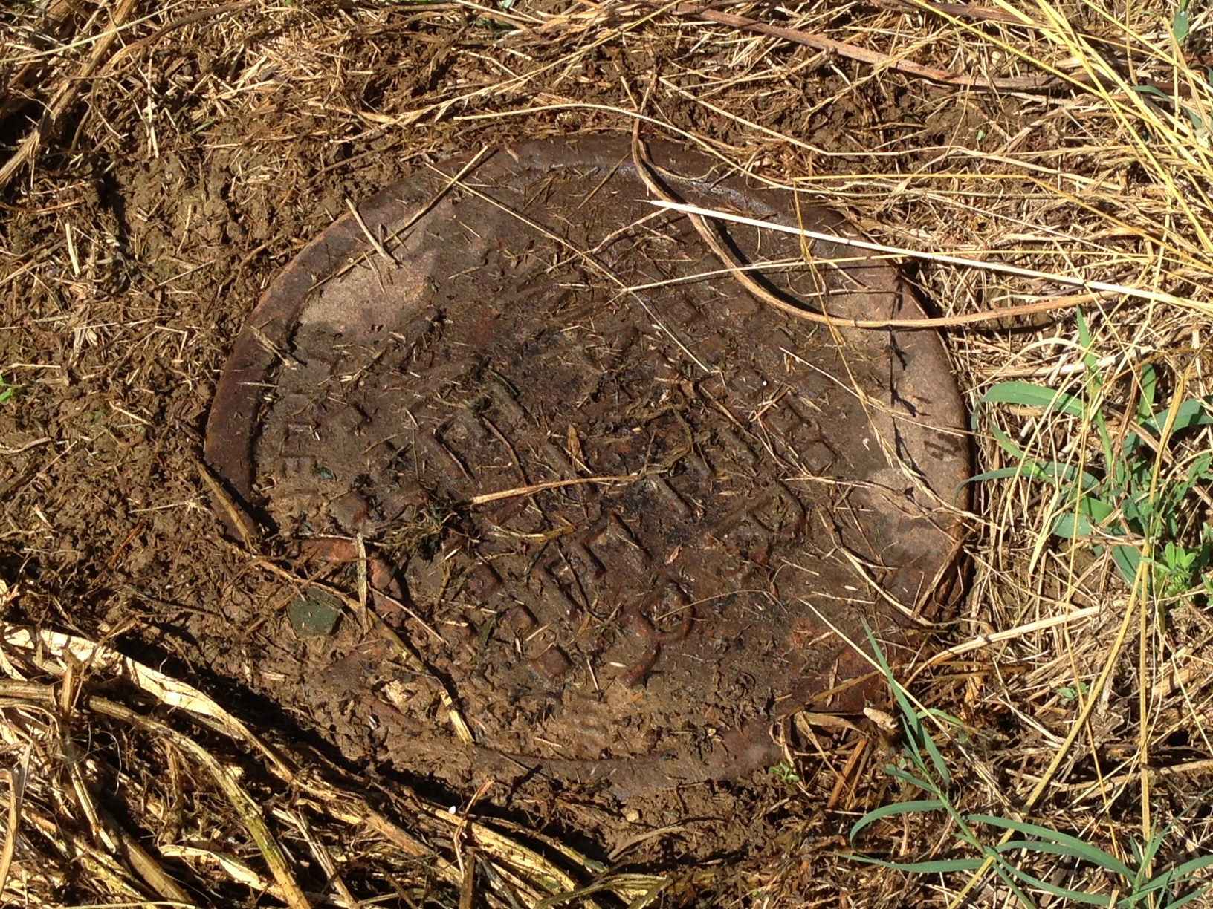
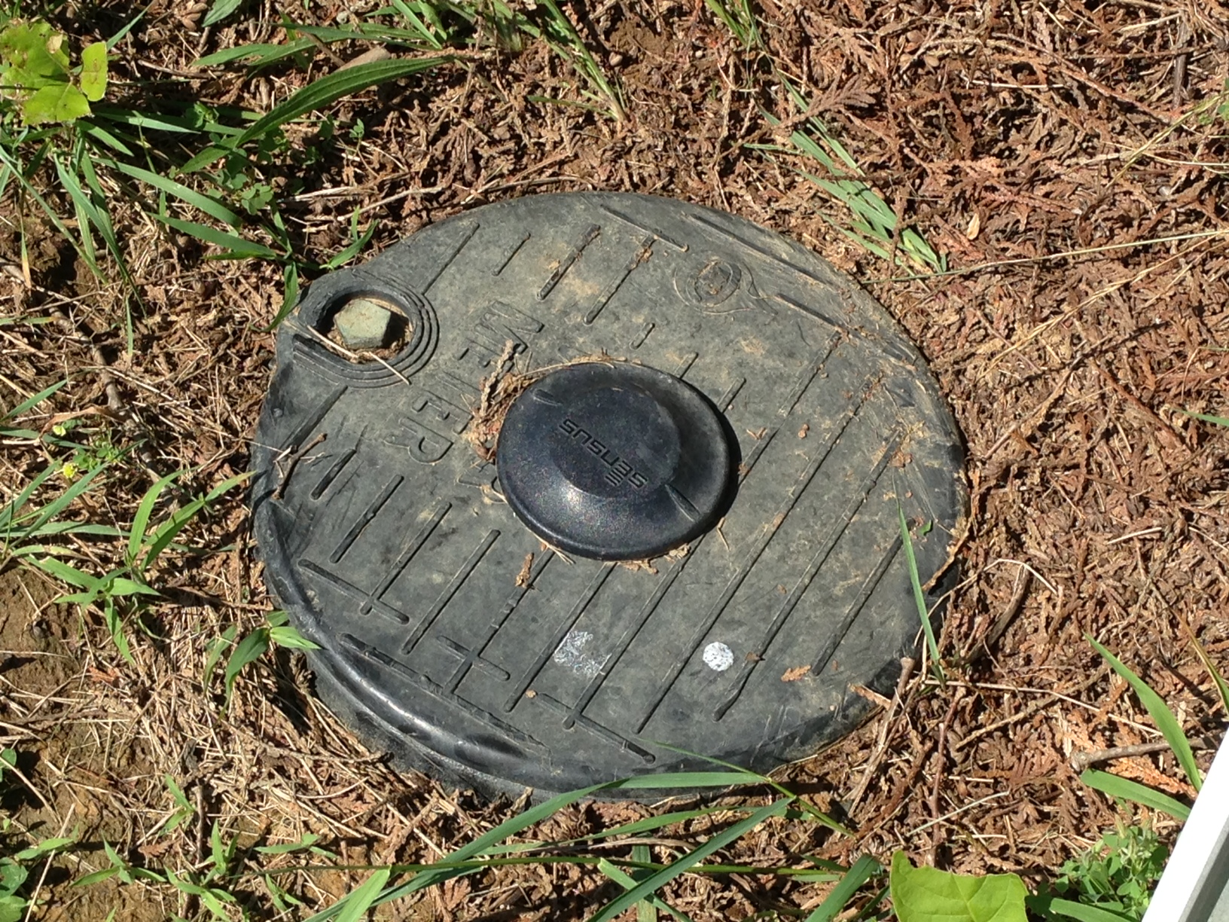
To open your crock, you will need to loosen the bolt on the lid. Once loosened, you can remove the crock lid by hand. Be aware that insects and small animals often hide in these crocks.
Plastic Crock Lid
Metal Crock Lid
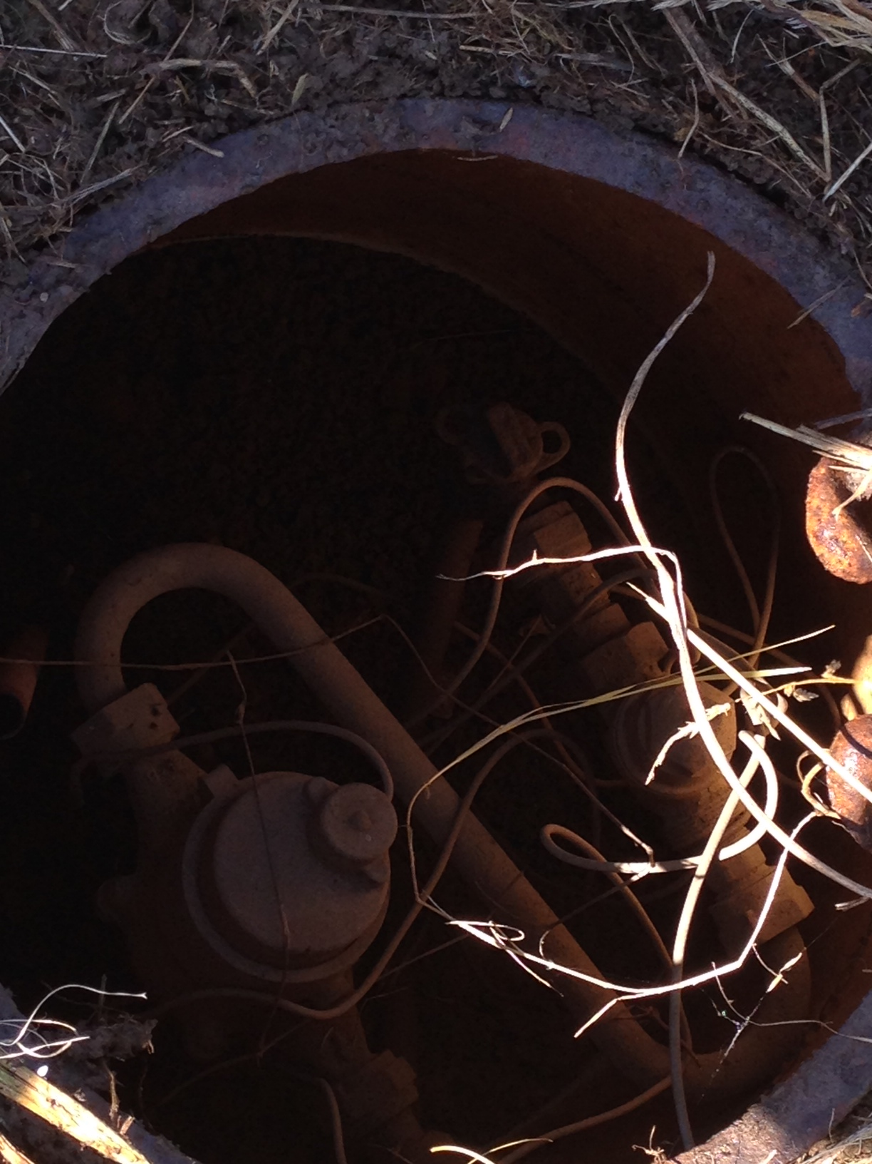
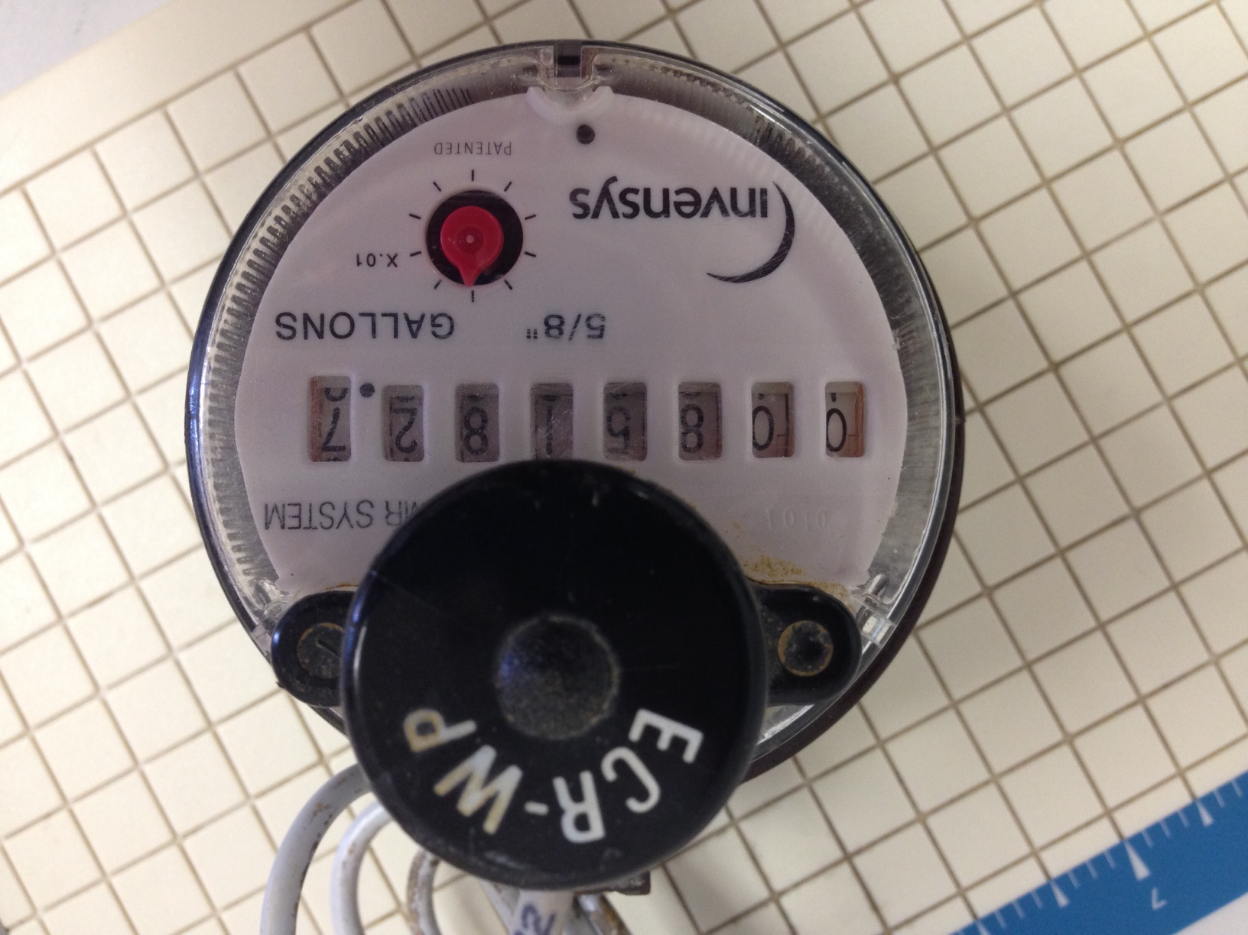
A meter like this lies beneath this caked on mud.

You may need to clean off the top of your meter to be able to read it. Mud and moisture over time can create a thick layer covering your meter. Use a spray bottle and a rag to soften and wipe away this layer.
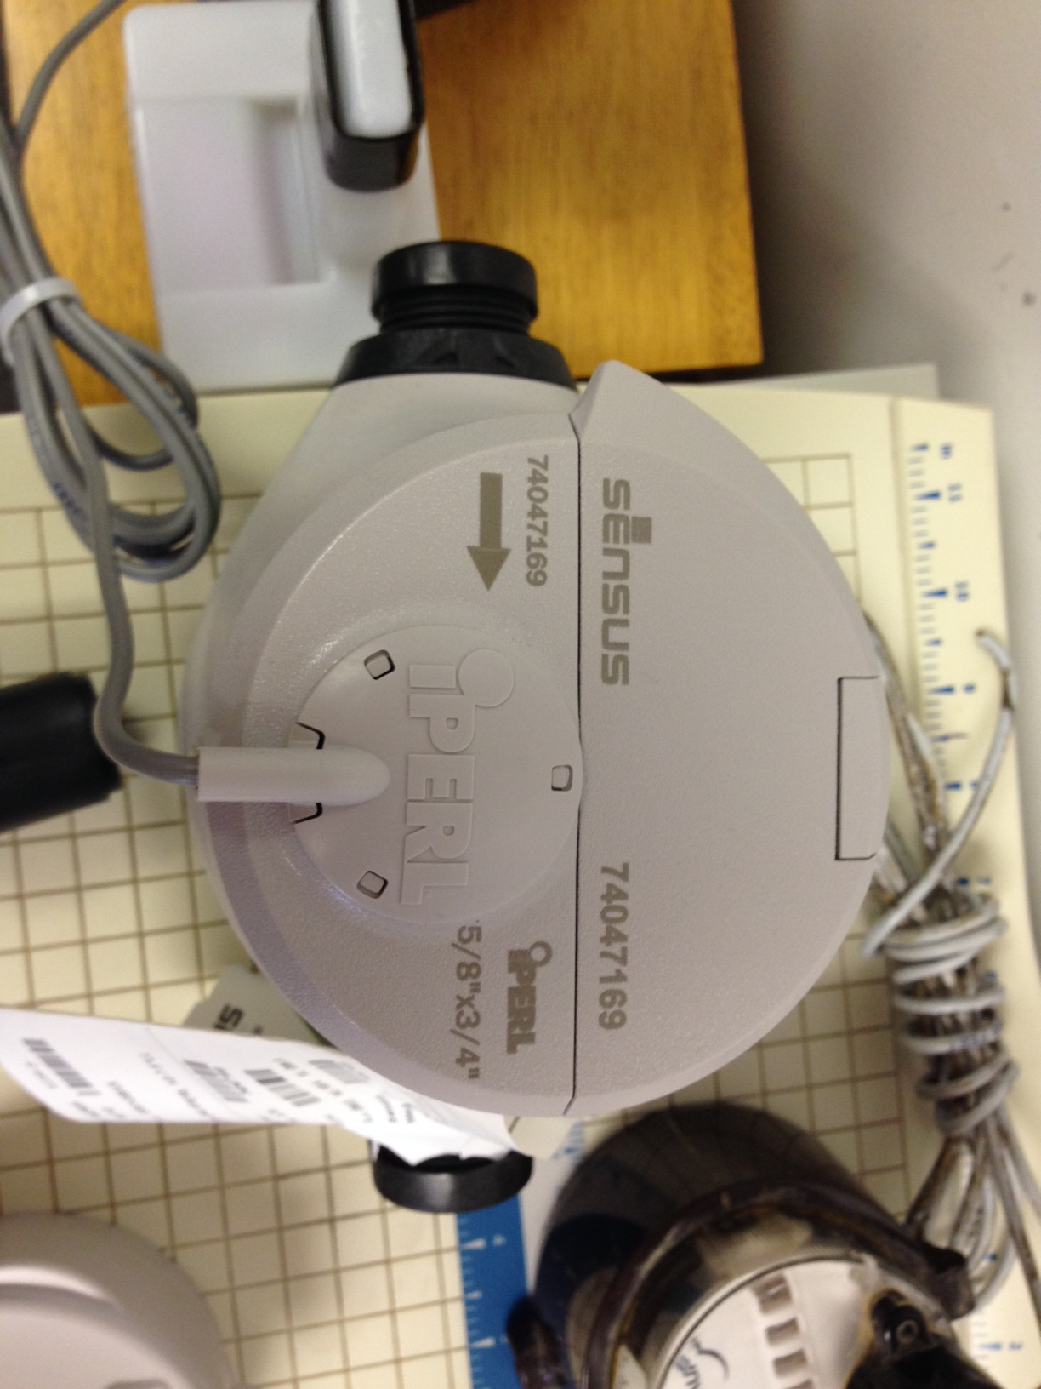
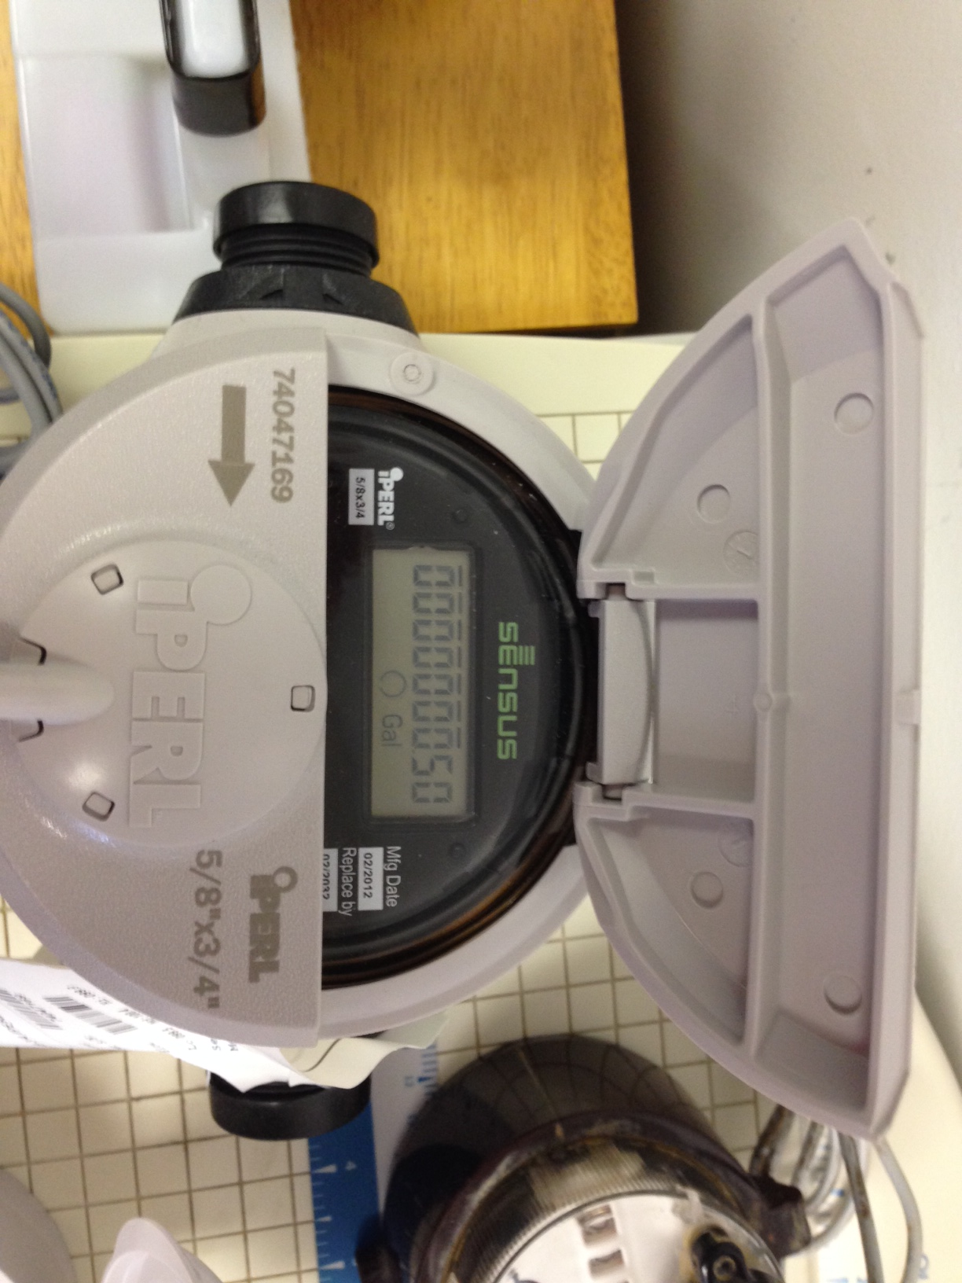
Your meter could be a newer flip top model. Click here for more information on these models: SR II

The meter has two readings. One is your general meter reading that looks like the odometer on your car. The other reading is a small dial called a “leak detector.” If all of the water in your house is off but the leak detector is spinning, then you have a leak. Keep in mind, small drips from a faucet may not be enough to spin the leak detector but can still add up over time.
The red dial is the leak indicator. If it is spinning, and all water is off in your house, you have a leak.

Some of our newer digital models do not have a leak indicator but detect a lot lower flow of water. Open the flip top, close it, and then open it again to read to the hundredth of a gallon of water passing through the meter. If the numbers are turning then you have a leak.

Remember: A leak only gets worse over time if not repaired.

Video Guide

This instructional video explains the process of how to use your meter to check for leaks.

Video 1

